MC310R
RECEIVER MANUAL

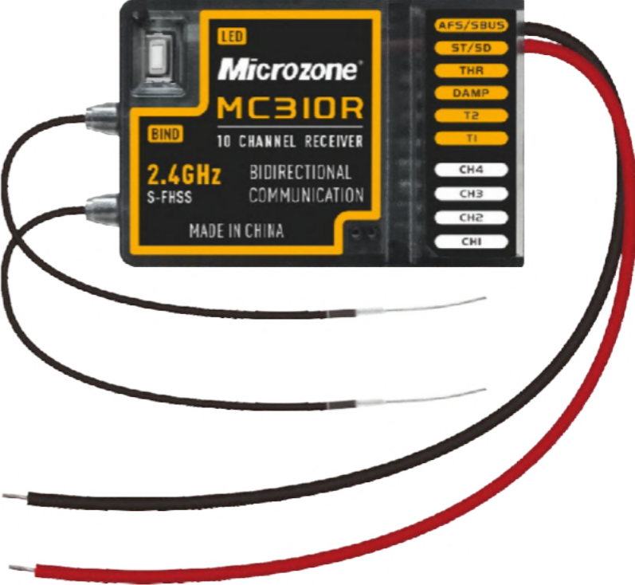

PLEASE READ THE INSTRUCTION MANUAL BEFORE USE

RECEIVER FUNCTION NOTE
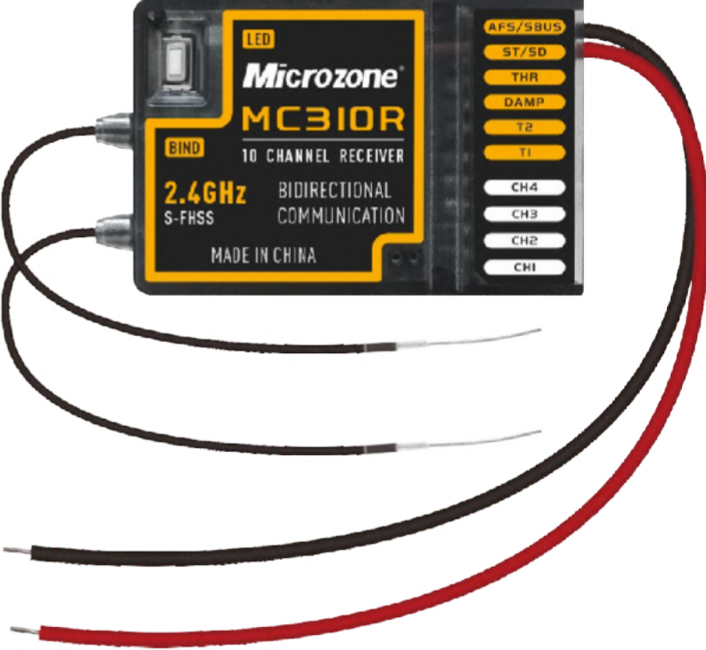
Indicator light
Bindbutt

Ante n

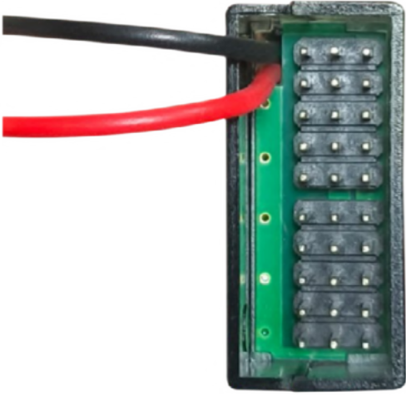
Attention: for voltage
electrode (–)
Voltage detection positive terminal (+)
9 PWM signals
Earthing (GND)
detection only, not for supply electricity use
Voltage detection negative

1 SBUS signal / 1 PWM signal

Connect +5V

CH1-CH4 (left and right joysticks) : time variation of 1000 us – 2000 us, intermediate value 1500 us ± 20 us T1–T2 (push rod) : minimum value signal 1000 us – intermediate pause 1500 us – maximum value signal 2000 us DAMP (damper) : minimum value signal 1000 us – intermediate pause 1500 us – maximum value signal 2000 us THR (throttle) : outputs a linearly varying signal, minimum value 1000 us – maximum value 2000 us
ST (start) : minimum value signal 1000 us – maximum value signal 1500 us change SD (stop) : minimum value signal 1500 us – maximum value signal 2000 us change AFS (car light) : minimum value signal 1000 us – maximum value signal 2000 us SBUS : output high-level value 3.3V, output period 14 ms
PWM signal : the high level is 3.3V, 14 ms one cycle, as shown in the figure below Voltage detection range : 5–72V

14ms
1000us

SBUS agreement:
Hardware section: (must) Software section:
- Communication interface USART
- Serial port configuration
100k baud rate (100 000 bits/s), 9–bit data bit, 2–bit stop bit, even parity (EVEN), No flow control, 25 bytes
- Agreement format The data comprises 25 bytes Start byte 0: 0x0f
Channel data bytes 1–22: [data 1]…[data 22] Each channel 11 bit, a total of 10 channels
Flag byte 23: in a state of loss of control 0x0c, normal receive 0x00 End byte 24: 0x00

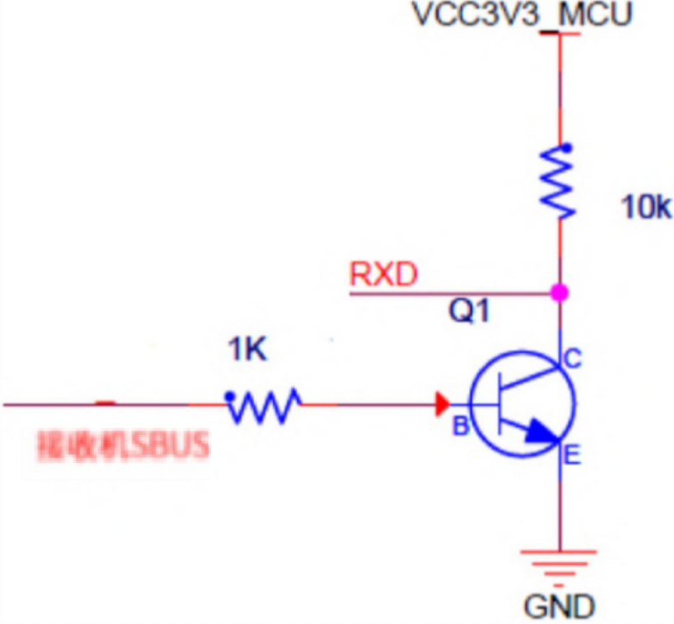
3904
ReceiverSBUS

FIRST TIME USE:
When unpacking using for the first time, please bind the remote control with the receiver, once bind is successful, success of the remote control and receiver for a short distance distance test, hand holding the remote control from the receiver 10 to 15 metres away, and then toggle the remote control joystick, to observe whether the device is controlled by the remote control, if controlled by a remote control, remote control and the receiver is working properly.

BIND:
Remote control is power off, after the receiver is powered up, the <Orange indicator light> always on, press the <Bind button> on the receiver, two <Indicator light> flash alternately, indicate that the receiver is in the bind mode, then power on the remote control, the receiver <Green indicator light> always on, indicate that the bind has been successful.

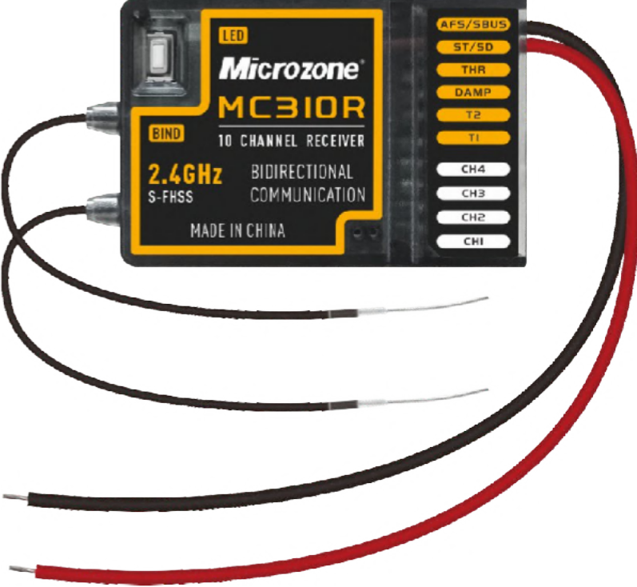
Indicator light
Bind button

FAILSAFE:
After the receiver goes out of control range or the remote control is accidentally powered off, the failsafe will be triggered;
Channels CH1, CH2, CH3, CH4, T1, T2, DAMP, THR, AFS output low level, and channels ST/SD output 2000us.

SAFE SHUTDOWN RECOMMENDATION:
To ensure the safety of your equipment and yourself, wait until the equipment motor has

stopped running, then turn off the power to the equipment, and finally turn off the remote control.

RECEIVER SPECIFICATIONS PARAMETERS

Model | MC310R
Color | Tea-coloured transparent
Applications | Remote control lawn mowers,  Remote control agricultural machinery, Transport tank vehicles, Photovoltaic cleaning robots
Channel output | (9 PWM signals, 1 SBUS signal) or (10 PWM signals)
Channel input | 1 voltage detection
Voltage detection range | 12–48V
Radio band | 2405MHz–2475MHz
Supply voltage | DC:4.5–6V
Voltage telemetry | Support
Failsafe | Support
Bind way | Button bind
Antenna type | External dual antenna
Size(length, width, height) | 50*31*14(mm)

Weight | 18g

MATTERS NEEDING ATTENTION

Before starting to use the receiver, carefully read the following precautions!
- This product is not a toy and is not suitable for children under the age of 12, adults should keep this product out of reach of children and keep it out of reach of children be careful when operating this product in the field.
- Do not use at night, in thunderstorms, snow, low visibility or other adverse weather conditions.
- Do not use the receiver in snowy or watery places, if rainwater enters the receiver, the circuit will be short-circuited and cannot be used.
- Signal interference may cause the receiver to go out of control, places where interference affects more than others are as follows:
  - Near the mobile phone signal transmission tower
  - Near high-voltage power lines and communication broadcasting antennas
  - Near the military radar launch tower
  - Commercial roads with complex wireless communications and human activity E.Navigation domain
- Please do not use this product after feeling tired, uncomfortable, drunk, or excited about drugs, otherwise it will cause serious injury to oneself or others the value of is.
- 2.4G radio band is completely different from the low-frequency radio band used previously, make sure that the product is operated within your line of sight when using it, as large obstacles can block the radio signal and cause loss of control of the receiver and the device.
- Make sure that the receiver and equipment are installed correctly, and that all servos operate in the same direction as the controls before use, otherwise serious damage to the equipment may occur.
- If the remote control distance continues to be long, loss of control may occur, so please shorten the control distance appropriately; low battery of the remote control, the remote control will not be able to send out a signal, which may result in loss of control, so when the remote control low battery alarm, please recharge the batteries as soon as possible.
- After keeping the remote control off, be sure to turn off the power to the receiver and then turn off the remote control, if you turn off the power to the remote control first and the receiver is still operating, the equipment may go out of control or the engine may continue to operate, resulting in a serious accident.
- Improper use of the receiver may cause serious injury or even death to the operator or others, to ensure the safety of you, others, and equipment, please be careful read this guide and follow the instructions.
- The remote control and receiver required for our company's 2.4G wireless transmission system are used in pairs, while other company products cannot be connected to our company's products.

